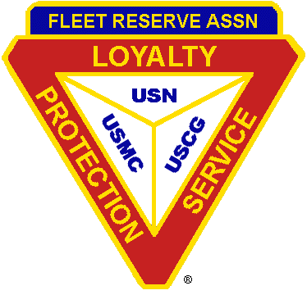
FLEET RESERVE ASSOCIATION

Representing all Enlisted Personnel of the
U.S. Navy U.S. Marine Corps U.S. Coast Guard

Atlanta Branch 89

MARCH – APRIL 2020 NEWSLETTER

President Secretary Treasurer Membership
Ernie Rose Denise Watkins Howard Hayes Wayne Barron
3493 Johnson Ferry Rd NE 3799 Donald Road SW 1091 Neva Drive SW 2427 Sunflower Dr
Roswell, GA 30075-5268 Smyrna, GA 30082-3501 Marietta, GA 30060-6179 Hoschton, GA 30548
770 993-6680 404 642-7020 678 402-6356/770 712-9707 678 689-7921
navy484blue@aol.com DZ6977@gmail.com howardshayes@gmail.com barronfra@gmail.com

MESSAGE FROM BRANCH 89 PRESIDENT

Hello Shipmates and Ladies,
At our January meeting the Southeast Region President, Laurie Bailey and her husband Tim visited. She shared thoughts on the Region and some insights of interest to our members. She also helped in the grading of our essays. After the meeting, she and Tim spent time fellowshipping with the shipmates and ladies.
The February meeting saw about 2 inches of snow fall while the meeting was going on. Even with the weather conditions several shipmates and ladies attended and we had two visiting prospective new members.
At the March 14th meeting, we will hold a Two Bell Ceremony and decide on the logo for a Branch 89 ball cap.
Our application for a memorial stone at the Canton, GA VA National Cemetery is still pending approval by the VA. We will keep you advised of progress.
The dates for the NAS Atlanta Reunion in Dillard, GA have changed to 13 and 14 May 2020. If you have never attended and would like information about the Reunion contact myself or Wayne Barron. Most regular attendees should have received information from Wayne recently. Wayne and Jane Lear, President have worked very hard to have another great reunion this year. Let’s do all we can to support them and show our appreciation.
That is about all from this end. I hope to hear from your end soon.
And “Beware the Ides of March”.
Yours in Loyalty, Protection and Service,
Ernie
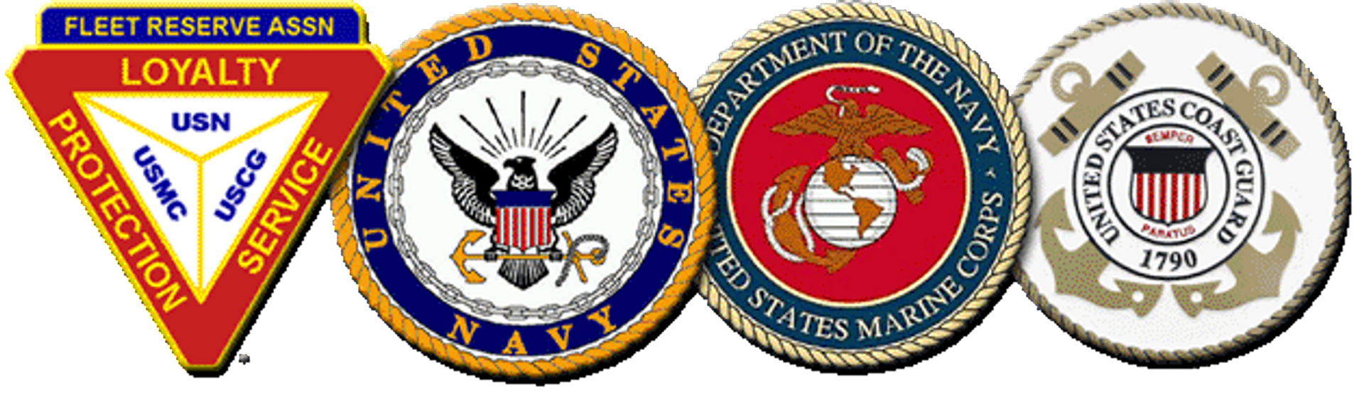

MONTHLY MEETINGS
Second Saturday of each Month *
At American Legion Post 160
160 Legion Drive
Smyrna, GA 30080
770 436-2501
*Unless otherwise announced.

UPCOMING MEETING DATES
At American Legion Post 160
Start Time: 10:00am or 1000 Hours
- March 14th, 2020
- April 11th, 2020
- May 9th, 2020
JUST FOR LAUGHS

One morning a radio announcer on the AFES station in Anchorage, Alaska was giving the time one morning at 8 AM. He said, for those of you in the Air Force, it is 8 Am. The Army, it is 0800 hours, the Navy, it is 8 Bells, and for the Marines, the little hand is on the 8 and the big hand is on the 12.
RECRUIT A NEW MEMBER TODAY
As an FRA member, you get answers to questions from friendly member-service staff with one phone call or e-mail. You also have access to the members-only areas of the website to read the latest association news, read our monthly publication FRAtoday, share your opinions in the community section, post reunions and subscribe to e-mail updates.

FRA members get up-to-date information on:
Legislation, Health care, Education benefits and enhancements, Veterans' service benefits
Survivor benefits opportunity to affiliate with a Branch (see Branch Locator) and much more!

A unique username and a password are required to create your membership online. FRA membership dues are as follows:

1 year for $40.00
2 years for $75.00
5 years for $180.00

Life Membership Fees
Effective 1 January 2017

Active Duty..............................$400
Ages 40 and younger................$450
Ages 41 to50.............................$425
Ages 51 to 60............................$390
Ages 61 to 70 ...........................$340
Ages 71 to 80............................$260
Ages 81 to 99............................$200
Ages 100 and older...................FREE
Your Mission • Your Voice

Dues Information

- Branch 89 will pay $15 of a two-year renewal
- $50 for a five-year renewal
- and 30 percent for Paid Up for Life Membership

In addition, if you attend 4 out of 6 meetings during each half of the year (January thru June, and July thru December), Branch 89 will have a drawing to pay for a PUFL Membership. If you are already a PUFL, you would be given that amount of monies that it would have cost you for the PUFL membership as of your age on the drawing date.
(Another reason to come to our monthly meetings!)
DATES TO REMEMBER______

MAR 1 – Peace Corps Day
MAR 12 – Girl Scouts Day
MAR 15 – Ides of March
MAR 17 – Saint Patrick’s Day

APR 1 – April Fool’s Day
APR 5 – Palm Sunday
APR 10 – Good Friday
APR 12 – Easter Sunday
APR 15 – Tax Day
APR 20 – Patriot’s Day
APR 22 – Earth Day
APR 24 – Arbor Day

LEGION FOOD PANTRY
Please remember to bring non-perishable food items for donation to the American Legion Post 160 Food Pantry. These donations assist our families and friends that are in need. All donations are greatly appreciated.
“The Power of Gratitude (Excerpts)”
By Ellen G Goldman, Health and Welliness Coach Cleveland Clinic Wellness

Robert Emmons and Michael McCullough are two leading American investigators of gratitude. They describe gratitude as personality strength – the ability to be keenly aware of the good things that happen to you and never take them for granted. Grateful individuals express their thanks and appreciation to others in a heartfelt way, not just to be polite. If you possess a high level of gratitude, you often feel an emotional sense of wonder, thankfulness and appreciation for life itself. Researchers are finding that individuals who exhibit and express the most gratitude are happier, healthier and more energetic.

Grateful people report fewer symptoms such as headaches, stomachaches, nausea, even acne, and spend more time exercising! And the more a person is inclined towards gratitude, the less lonely, stressed, anxious and depressed he or she will be.

